**Assessment Cover Page**

|  |  |
| --- | --- |
| *Student Full Name* |  |
| *Student Number* |  |
| *Module Title* |  |
| *Assessment Title* |  |
| *Assessment Due Date* |  |
| *Date of Submission* |  |

**Declaration**

By submitting this assessment, I confirm that I have read the CCT policy on academic misconduct and understand the implications of submitting work that is not my own or does not appropriately reference material taken from a third party or other source.

I declare it to be my own work and that all material from third parties has been appropriately referenced.

I further confirm that this work has not previously been submitted for assessment by myself or someone else in CCT College Dublin or any other higher education institution.

Contents

Introduction 1

Chapter 1 1

Chapter 1.1 1

Chapter 1.1.1. 1

References 2

**Introduction**

* Data analisys is widely used in housing to predict prices. Machine learning can be really useful to predict prices in the future or resolve the price of one property that we want to sell.
* This dataset contains a total of 13 variables and the goal of this project was to predict the prices. We decided to use two different methods, Random Forest Regressor and Support Vector Regression (SVR) and compare the results between each other through Cross Validation (CV), to compare what model is better on this case.

**Pre-processing**

**EDA**

For this analysis our data set is called Housing in format csv, with the function “df.head()” we can see the first five columns:

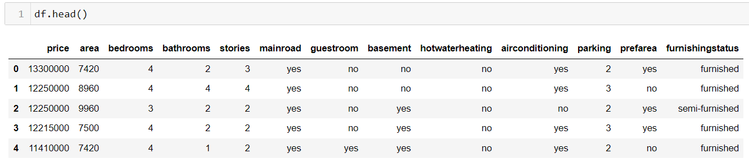

Fig 1

As we can see in the figure 1, we have six numerical values, and seven categorical columns. With the function info, “df.info()” we can observe that we have 545 rows or samples.

With the funciton info(), we can see the type of columns that we have as well.

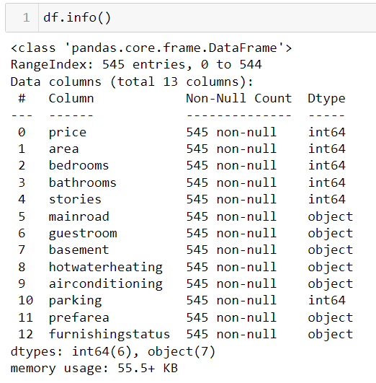

Fig. 2

All the columns are the same type that is supposed to be, any column with numerical values is type object, and also with the function “nan_count = df.isna().sum()” we can corroborate that there are not nan values (Fig. 3).

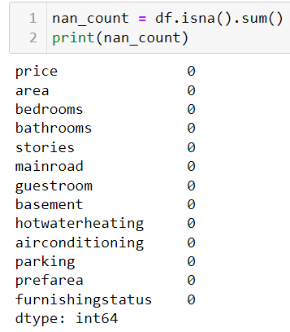

Fig. 3

For categorical data is important to convert this information in number and values, we use dummies to convert our values in 0 and 1, being 0 no and 1 yes,” pd.get_dummies(df)”

We can observe in the figure 4, that we have now 21 columns because our categorical data is split in 2 instead 1.

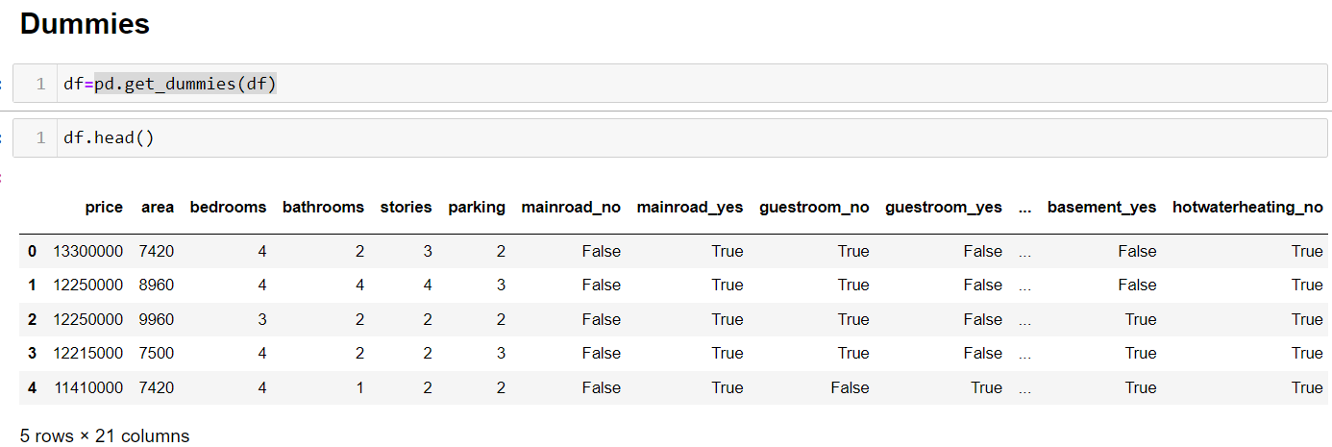

Fig.4

In the figure 5, we can observe the correlation between price and area, the first graph shows the correlation with the outliers and the second graph the correlation without them.

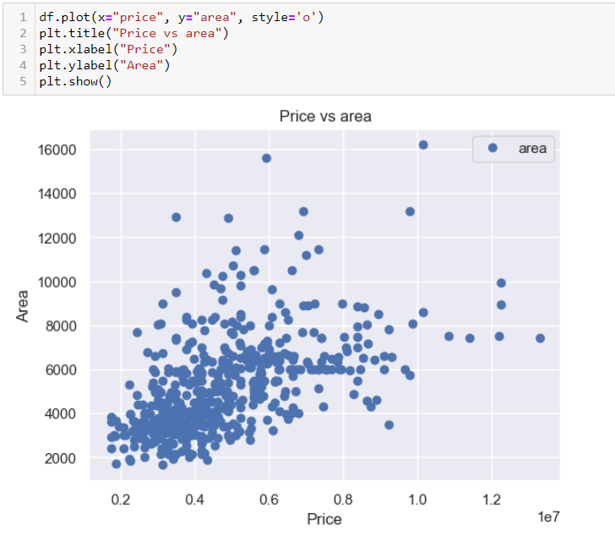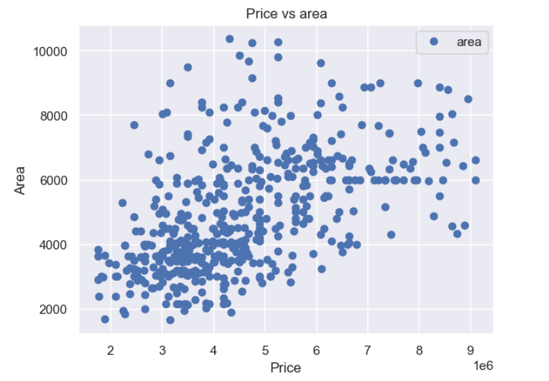

Fig 5

**Heatmap/ Correlation matrix**

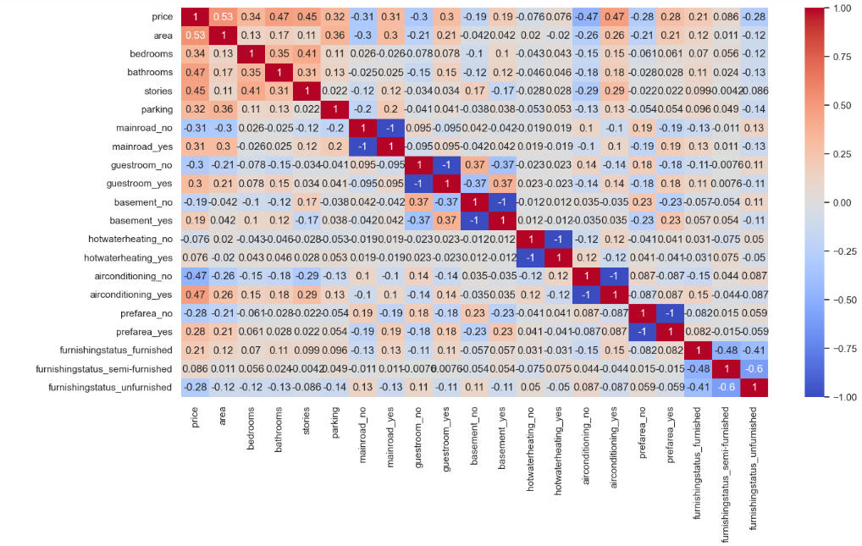

**Scaling our Data**

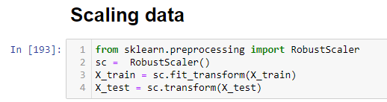

**Our Models**

**Splitting our data** (20%, 25% and 30%)

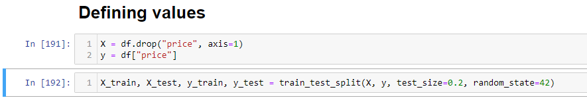

**Random Forest Regressor**

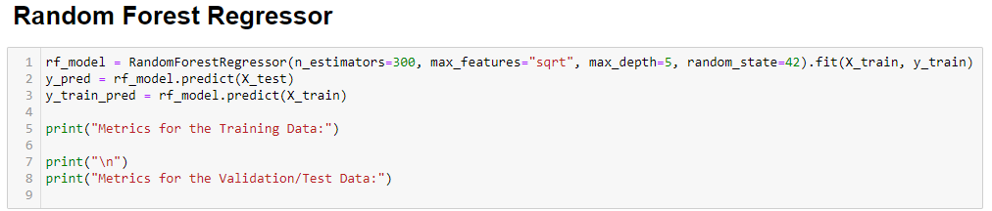

**Feature importance**

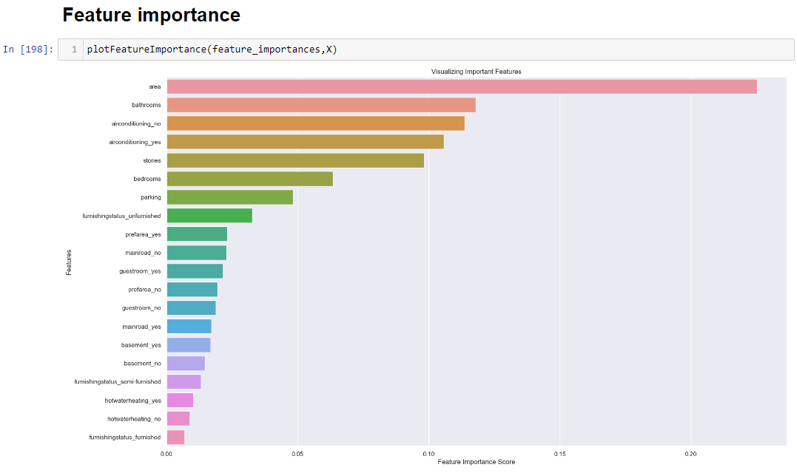

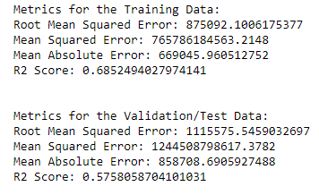

**Hypertuning our Random Forest Regressor**

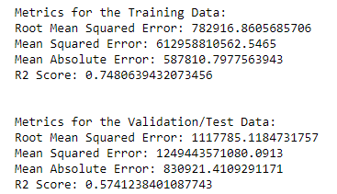

**Support Vector Regression**

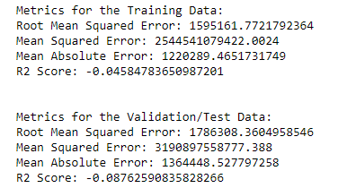

**Hypertuning Support Vector Regression**

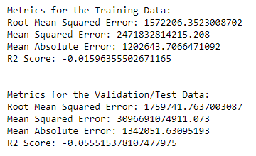

**Feature importance SVR**

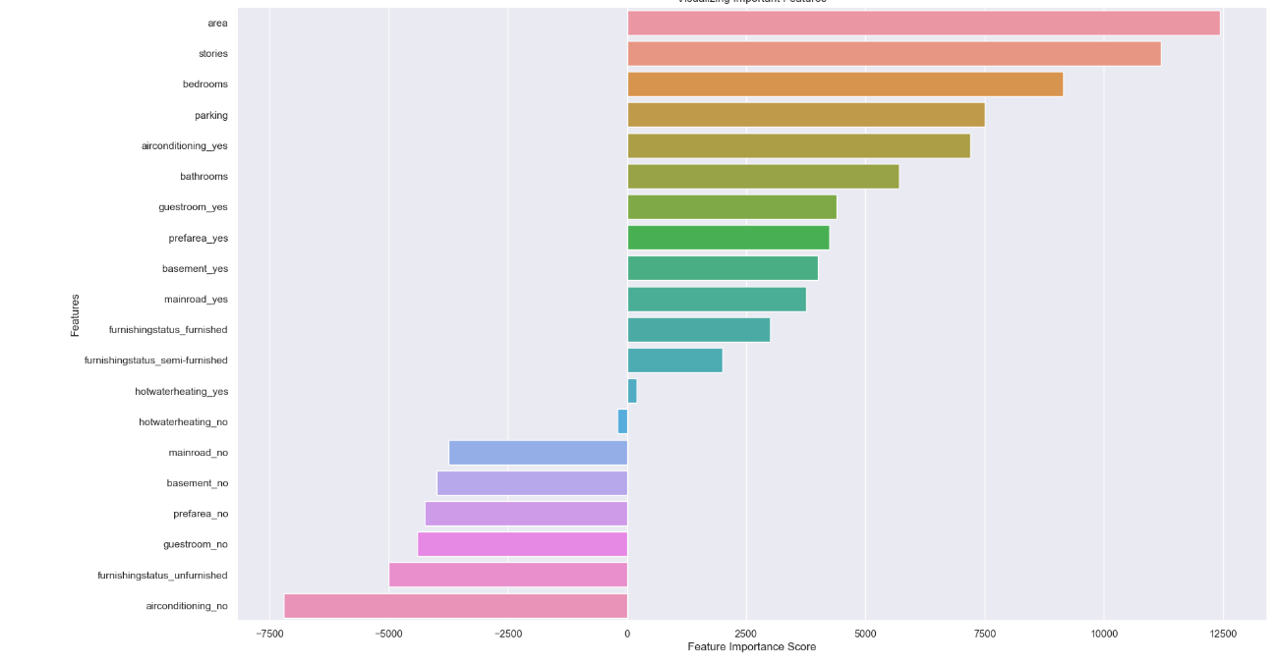

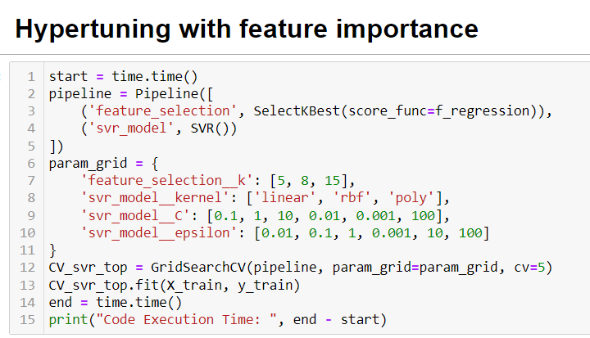

# Cross Validation

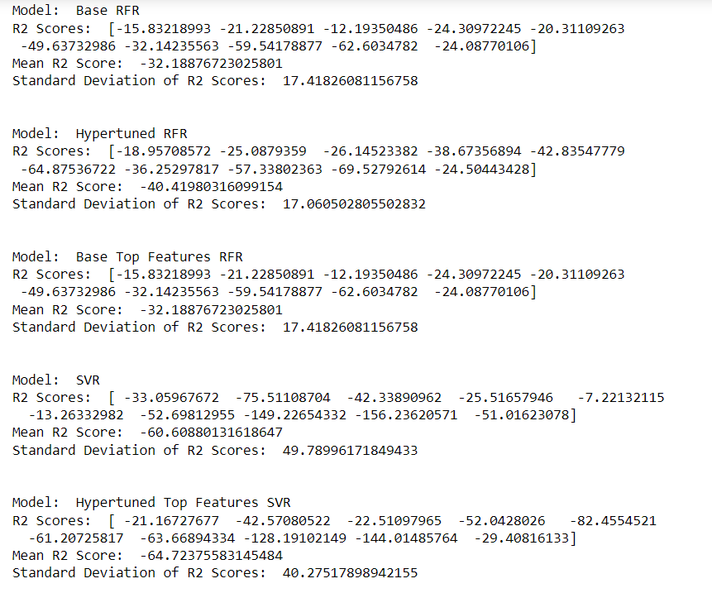

What are the most important features for predicting X as a target variable?

Which classification approach do you prefer for the prediction of X as a target variable, and why?

The student would need to consider the following instructions (a - d) during the development of this project.

a) Logical justification based on the reasoning for the specific choice of machine learning approaches.

b) Multiple machine learning models (at least two) using hyperparameters and a comparison between the chosen modelling approaches.

c) Visualise your comparison of ML modelling outcomes. You may use a statistical approach to argue that one feature is more important than other features.

d) Cross-validation methods should be used to justify the authenticity of your ML results.

1. A clear introduction, motivation, a description of the problem domain, and an explanation of how the project's goals are justified using Prediction / Classification algorithms. (20 marks)

2. Characterization of data, pre-processing, explanation and description of techniques used for the variation in the accuracy across three training splits (20%, 25% and 30%) using cross validation techniques. (30 marks)

3. What is the primary purpose of hyperparameter tuning in machine learning? Could you elaborate on specific hyperparameter tuning techniques (e.g., GridSearchCV) applied to machine learning models to find optimal parameters? (25 marks)

4. Interpret and explain the results obtained, discuss overfitting / underfitting / generalisation, provide a rationale for the chosen models and use visualisations to support your findings. Comments in Python code, conclusions of the project should be specified at the end of the report. Harvard Style must be used for citations and references. (25 marks)

● Clearly detail the number of words used in the report. (per section)